Standard Operating Procedure (SOP) for Screening Banana resistance against Fusarium Wilt (Foc Race 1)

Authors & Contributors
K. Jomanga, R. Kanaabi, G. Mwanje, N. Kinalwa and G. V. Nakato*
*Correspondence: V.Nakato@cgiar.org

1. Introduction
Banana (Musa spp.) is an important staple and source of income for many people in developing countries. Fusarium wilt, caused by Fusarium oxysporum f. sp. cubense (Foc) race 1, is a major disease, causing yield losses of up to 100% (Arinaitwe et al., 2019). Foc. once introduced into farmer's fields, very little can be done to eradicate the pathogen and there are no effective management strategies. It is widely reported that the breeding and selection for disease tolerance or resistance is the most effective and sustainable management option available for smallholder farmers (Buddenhagen, 2009). Therefore, phenotyping of quantitative disease resistance (QDR) through exposure of plants to pathogens and visual observation of disease symptoms is an important stage in many plant-breeding programmes (Skelsey and Newton, 2014).

2. Purpose
This SOP document serves a purpose of guiding Banana Plant breeders, Phytopathologists, Technicians, and Data analysts during the screening of banana genotypes for resistance to banana fusarium wilt. It is designed to ensure consistence and minimization of errors.

3. Scope
This document clearly describes procedures and practices involved in screening banana genotypes for Resistance to Banana Fusarium wilt, (Race 1). It outlines, planning for the experiment, Genotype selection including checks and controls, Experimental design and layout, Inoculum preparation and infection, Data collection and Analysis.

4. Definition of terms
- Hybrids: Varieties of banana plants generated after crossing two different varieties
- Checks: Known Varieties susceptible or resistant to the constraint used as controls in experimental trials
- Controls: Land races used as controls (Land race are varieties of banana plants commonly cultivated for food).

5. Roles and Responsibilities
Research Technicians are responsible for Tissue Culture Lab plantlet generation, Inoculum preparation, Inoculation Data collection, Data curation and Analysis.
Pathologists/Research Assistants is/are responsible for experiment Planning and Supervision.
Pathologist/Breeder are responsible for Data Analysis and publications.
Field Assistants are responsible for Data collection and experiment monitoring.

6. Procedure/Protocols
Step 1. Experimental Planning:
It involves listing all required materials/requirements to establish a successful screening experiment.
List all Materials:
Test genotypes
Checks/Controls:
Land Races: Mchare, Matooke, Plantain
Susceptible: Sukali Ndizi,
Resistant: Calcutta 4, Matooke
Culture Media requirements:
PDA half strength/ sabourand Dextrose Agar (SDA), Deionised water/distilled water, Petri dishes (90-mm-diameter), Analytical balance, Weighing boats/trays, Spatula, 1-L Schott bottles, Autoclave, Petri-dishes (90mm, 60mm), Anti-biotics
Other Materials: 2Kgs Plastic pot/Polyethylene bags, Forest soil, Seedling under hardening-off, Millet seeds, Gloves, 1L Schott bottle or 250ml Erlenmeyer flasks, Sterile distilled water, Autoclaved paper towel/tissue paper, Measuring cylinder (1L), Alcohol (70%), Scalpel/knife, clean bag/s of 15-20 kgs size.
Plan Experimental design: It should be selected depending on prevailing conditions i.e., number of genotypes, space, among others. For example, Partially Replicated Design (P-rep) in case of many genotypes and limited space.
Select Experimental site: Preferably Screen house/Glass house

Step 2. Plantlet Preparation (Tissue Culture and Nursery)
- Pathogen-free micro-propagated banana plantlets to include Test genotypes and Checks/Controls listed in the planning phase (Refer to step 1) are propagated from any reputable Tissue Culture laboratory and used for the screening purposes.
- The plantlets are transferred for Hardening in the Humid chamber and screen house (Nursery) for 2-3 months to attain a height of 25-30 cm, and later transferred to the experimental site (Screen house).

NB: Refer to Banana Weaning SOP (IITA-BP-SOP06-06) for full details on weaning banana plantlets.

Step 3. Inoculum Preparation
Inoculum is prepared within 2-3 weeks before the end of the plantlet hardening in step 2 above.
Archived Foc race 1 isolates are retrieved from -20⁰C storage
NB: In case of fresh field isolation of Fusarium oxysporum f. sp. cubense (Foc) race 1 Refer to Annex 1.2 for procedures.
It`s important that enough Foc macroconidia, microconidia and chlamydospores are produced on full strength solid media preferably Potato Dextrose Agar/ Sabourand Dextrose Agar so as to produce a culture to inoculate the inoculation media, (Millet).
Step 4 Millet seeds preparation and inoculation of millet seeds
- A known weight of millet seeds depending on the need in a 15-20 kg bag are soaked in water for 6 hrs, then allowed to partial dry to remove excess water.
- Autoclaving of millet in a bag at 121⁰C for 2 hrs and later allowed to cool under the lamina flow/bio safety cabinet.
- 2 fully grown 90mm petri-dishes of Foc race 1 mycelial are used to inoculate 1 kg of sterilized millet kernels. This is done by cutting the culture from the margins of the petri dish.
- The mixture is thoroughly mixed then incubated at 25⁰C in a dark room/incubator.
- After white fungal growth begins to show on the surface of the millet kernels, the bags are shaken every 2 days to distribute the spores equally and to prevent the kernels from clumping together.
- In case the mixture is dry, sprinkle sterile water to make it moist during shaking.
- After 14 days, individual millet kernels will appear discolored with a reddish taint.
- A small sample removed from each bag and placed onto PDA to ensure that they are colonized by Foc only. The millet-inoculum are ready for inoculating banana plantlets.

Step 5. Designing the Experimental layout
- A partially replicated Block (P-rep) design is adopted for this SOP, since it allows running the experiments in batches when planting materials are many and not available at the same time. However other designs can be adopted depending on the prevailing conditions.
- This design is developed using an updated and licensed version of the Cyc Design software.

Step 6. Setting up the Experiment and Inoculation
- The screen/glass house is prepared/cleaned where the experiment is to be established.
- The planting pots containing forest soil are placed into position following the layout deigned in Step 3
- Transfer the grown plants from the Nursery to the experimental site from Step 2 above.
- Carefully transplant the weaned plants into planting pots at exact positions following the designed layout from Step 3.

NB: Check the labels for all plantlets to be used for screening experiment to ensure each genotype is placed at the right position.

Step 7. Plant Inoculation and incubation
- Pots in the screenhouse are filled with 650g of sterile forest soil (approximately 1/3 of 2kg).
- A layer of 50g of thoroughly mixed Foc-infested millet kernels is added on top of the 650g soil previously added.
- Then banana plantlets are transplanted into the pots ensuring the roots are in contact with the inoculum.
- The pots are then filled up with sterile forest soil up to a mark of 2kg.
- The banana plantlets are incubated in glasshouse at a temperature range of 20-25⁰C and irrigated regularly with tap water.
STEP 8. Evaluation/Data Collection
Evaluation consists of visual observations of typical external and internal symptoms of Planted genotypes. The following variables should be measured:
8.1 External Symptom Evaluation
- Wilting and yellowing of older leaves around the margins are among the important symptoms to evaluate.
- The yellow leaves may remain erect or collapse at the petiole.
- Sometimes, the leaves remain green, except for spots on the petiole, but still snap.
- The collapsed leaves hang down the pseudostem like a skirt.
- Eventually, all the leaves fall down and dry up.
- Splitting of the base of the pseudostem is another common symptom. Other symptoms include irregular, pale margins on new leaves and the wrinkling and distortion of the leaf blade.
- The evaluation uses a scale of 1 to 5 as described by (Viljoen et al., 2016).
- Evaluation starts every two weeks from second week after inoculation day to 10-12 weeks.

Data Collection
Every after two weeks after inoculation, disease symptoms are evaluated using scales of 1 to 5 per genotype and recorded in a Field book Android App.

External Symptom evaluation scale:
Description | Scale
No symptoms / plants appear healthy | (1)
Stunted leaves less than 1/3 of total leaves | (2)
Light wilt (1/3 - 2/3 of total leaves) | (3)
Wilting (greater than 2/3 of leaves) | (4)
Total wilt / dying | (5)
Table 1 External Symptom Scale

8.2 Internal Symptom Evaluation
- Internal symptom evaluation involves examination of corm discoloration at experiment termination usually 10 to 12 weeks after inoculation.
- Internal symptom develops first before the first appearance of the external symptoms.
- The characteristic internal symptom of Fusarium wilt is vascular discoloration, which varies from pale yellow in the early stages to dark red or almost black in later stages.
- Internal symptoms first develop in the feeder roots, which are the initial infection sites.
- The fungus spreads from the edge toward the inner part of rhizome and then to the pseudostem.
- The corm/rhizome internal symptoms can be assessed by splitting the into two halves either longitudinally (Arinaitwe et al., 2019) or transversely (Viljoen et al., 2017), preferably longitudinal because it captures more damage.
- Evaluate the Symptoms on the corm using a scale of 1 to 6.

6.2 Data collection for Internal Symptoms
Data is recorded immediately to prevent errors that might result from normal tissue degradation during the termination process. Corm discoloration per plant is evaluated and recorded in the field book App with traits to include:
- Corm discoloration on scale of 1-6
- Take a photo
Description | Scale
Corm completely clean, no vascular discoloration | (1)
Isolated points of discoloration in the vascular tissue | (2)
Discoloration of up to one-third of vascular tissue | (3)
Discoloration between one-third and two-thirds of the vascular tissue | (4)
Discoloration greater than two-thirds of the vascular tissue | (5)
Total Discoloration of the vascular tissue | (6)
Table 2 Internal Symptom Scale
NB: For internal symptom Visual/diagrammatic representation refer to Annex 1.5

STEP 7 Data Curation and Analysis
Disease Severity Index, (DSI) is calculated from the data collected and genotypes categorized into Resistant, Tolerant, Susceptible and Highly susceptible. Analysis of variance is also conducted to check whether there are variations among the banana genotype means. Mean separations (Fishers Protected for Mean separation) are performed to check the significant difference among the genotype means, Campbell & Madden (1990).
Disease severity index is calculated according to the formulae below:
DSI (%) = [sum (class frequency × score of rating class)] / [(total number of plants) × (maximal disease index)] × 100.

7. References
Dita, Miguel; Teixeira, Luiz; Li, Chunyu; Zheng, Sijun; O’Neill, Wayne; Daniels, Jeff; Pérez-Vicente, Luis; Carreel, Françoise; Roussel, Véronique; Carlier, Jean; Abadie, Catherine; Carpentier, Sebastien Christian; Iyyakutty, Ravi; Kissel, Ewaut; van Wesemael, Jelle; Chase, Rachel; Tomekpe, Kodjo; Roux, Nicolas. (2021). Practical guidelines for early screening and field evaluation of banana against Fusarium wilt, Pseudocercospora leaf spots and drought. Bioversity International. Montpellier, France. 83 p
Arinaitwe, I. K., Teo, C. H., Kayat, F., Tumuhimbise, R., Uwimana, B., Kubiriba, J., ... & Othman, R. Y. (2019). Evaluation of banana germplasm and genetic analysis of an F1 population for resistance to Fusarium oxysporum f. sp. cubense race 1. Euphytica, 215(10), 1-11.

8. Annex: Forms/Templates to be used for monitoring and data collection
1. Isolation of Fusarium oxysporum f. sp. cubense (Foc) race 1
1.1 Fusarium diseased sample collection
- The sample is taken from symptomatic plant pseudostem and should be taken from as low in the pseudostem as possible by avoiding areas where decay is advanced.
- Vascular bundles/Xylem strand are keenly cut from the leaf sheath and then put in between sterile paper towel and squeezed to remove excess water.
- Samples should be kept in sterile paper towel and then in a paper bag or wrapped in paper until the strands becomes dry by changing the paper towel.
- Label the sample properly and store in a dry shelf.

1.2 Fungal isolation from affected colored strands.
- Isolation can be attempted as soon as the strands with vessels are dry.
- Plate small sections (3-6 mm long) of the tissues with vascular vessels in Petri plates with antibacterial agent (i.e., streptomycin sulfate1.2 mL / 240 mL of full-strength PDA).
- Check if there is growth of fusarium from 2 to 4th days.
- If there are contamination of bacteria, the fungal growth could be masked, then allow the sample to dry more and increase the streptomycin sulfate in the media.
- Then you can do single spore by picking a single conidia/spore from each specimen.
1.3 Isolation from soil
- Collect a soil sample from the first 25 cm depth and store in a paper bag.
- Let samples air dry in the more aseptic conditions for 24-48 hours
- Grind the larger particles in a mortar
- Prepare a soil suspension in sterile water in a proportion of 1:50 soil weight / water volume (If the suspension is too concentrated because of high Fusarium population in the sample, a 1:100 proportion can be prepared).
- Shake the suspension for better release and distribution of soil particles and fungal structures.
- Dilute 1 mL suspension in 10 cm Petri plates with modified K2 media at close to melting temperature to achieve a good dispersion of the soil in the culture media.
- 1 mL of suspension can also be distributed on the surface of the plate with solidified K2 media.
- Distribute the suspension as uniformly possible and allow it to stand for two minutes. Remove excess soil suspension from the plate and incubate it at 27°C upside down.
- Recovered colonies are transferred to other appropriate media to obtain single conidial isolates.
1.1.4 Single spore isolations (single conidia).
- Fusarium oxysporum single spore isolations are obtained by the plate dilution method and streaking plates (showed ahead).
- For both methods: Collect a scrape of sporulating hyphae from cultures growing on PDA (¼ strength) and dissolve in 10 mL sterile distilled water in test tubes.
- From an initial suspension, a dilution serial can be prepared.
- Pipette or streak 1 mL of each of the dilutions on water agar.
- Using a tereo microscope pick and incubate a single spore on PDA.
1.1.5 Media preparation and incubation of Foc-race 1
- The media is preparation from 39 g of PDA powder (full strength) are added to 1L Schott bottle and fill up with deionised water to a 1 litre mark.
- Then, the media is autoclaved at 121°C for 20 min; and cooled down to 50°C.
- Additional of anti-biotics may be necessary sometimes at temperature (50-60°C), to prevent or reduce contamination
- Pour into 90-mm/60mm Petri dishes and store at 4°C until use.
- Identified VCGs virulent Foc isolate is transferred onto dextrose agar (PDA), allowed to geminate on agar for 7 days in a petri-dish at 25⁰C on a bench or in the incubator.
- The isolate is ready for millet seeds inoculation.

1.2 Diagrammatic illustration of Longitudinal sections of Internal Symptom (Arinaitwe et al., 2019)
Internal Corm Rating/Scores | Description
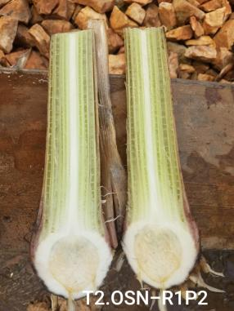  Image 1: Scale 1 | Corm completely clean, no vascular discoloration (1)
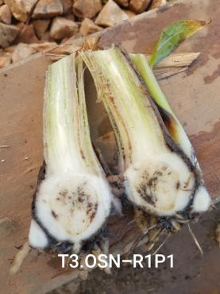  Image 2: Scale 2 | Isolated points of discoloration in vascular tissue (2)
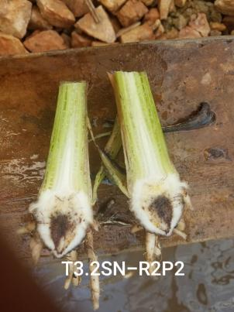  Image 3: Scale 3 | Discoloration of up to one-third (1/3) of vascular tissue (3)
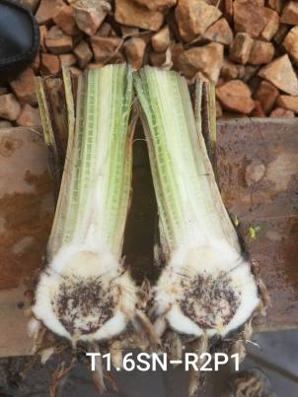  Image 4: Scale 4 | Discoloration of between one-third and two thirds (1/3 - 2/3) of vascular tissue (4)
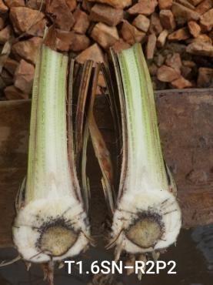  Image 5: Scale 5 | Discoloration of greater than two-thirds (2/3) of vascular tissue (4)
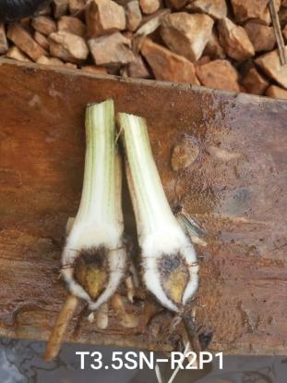  Image 6: Scale 6 | Total discoloration of vascular tissue (5)

1.3 Diagrammatic illustration of Transverse sections of Internal Symptom (Viljoen et al., 2017)
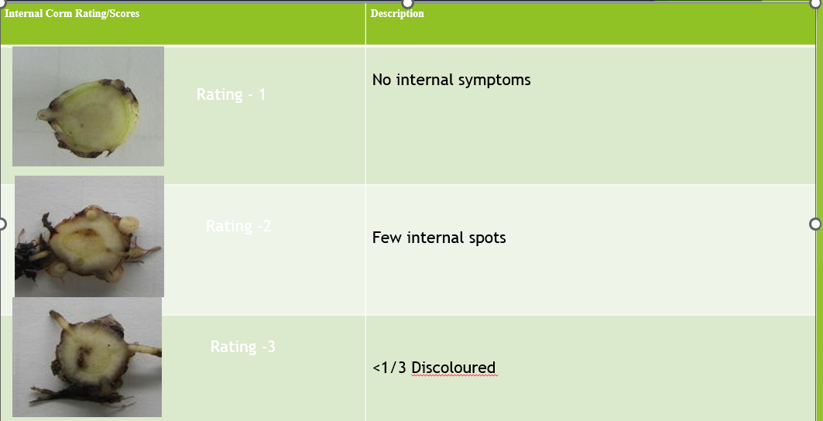
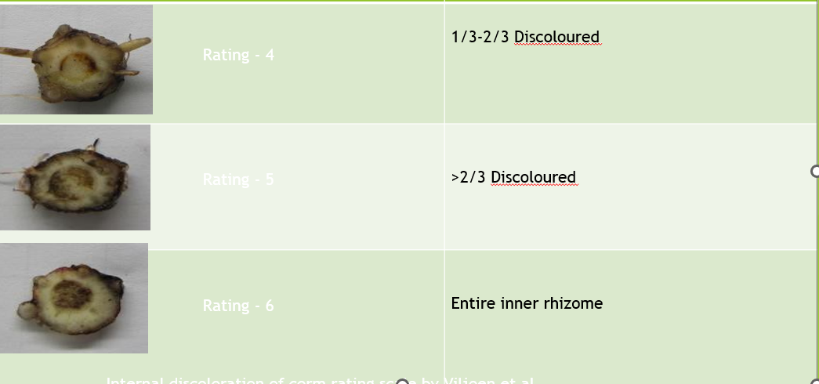

2. Flow Chart for the Screening of Banana Genotypes Against Fusarium wilt Tropical Race 1
