Standard Operating Procedure (SOP) for screening for resistance to Black Sigatoka (P. fijiensis) in Bananas

Authors & Contributors
N. Kinalwa, C. Serebe, G. Mwanje, R. Kanaabi, J. Kisitu, M. Mulongo, G.V. Nakato*

*Correspondence: V.Nakato@cgiar.org

1. Introduction
Banana, and especially the cooking type known as East Africa highland banana, is a vital staple food and income crop for over 80 million people in East Africa. However, productivity has been declining, partly due to diseases such as Sigatoka leaf diseases. Sigatoka disease of banana is caused by fungi of the genus Pseudocercospora (previously called Mycosphaerella). Species associated with Sigatoka disease include; P. fijiensis, causal agent of black Sigatoka, P. musicola of yellow Sigatoka (Irish et al., 2006) and P. eumusae of Eumusae leaf spot (Carlier et al., 2000; Chang et al., 2016). Yellow Sigatoka symptoms are characterised by oval to round necrotic lesions, which first appear pale yellow on the lower surface of the leaf, and this differentiates it from black Sigatoka at early stages of lesion development. Damage is manifested as necrotic leaf lesions that reduce the functional leaf area and photosynthetic capacity, resulting in reduced crop yield and fruit quality leading to banana yield losses ranging from 20-50% (Carlier et al., 2000). Use of resistant cultivars is the most effective and sustainable solution to manage sigatoka. Therefore, screening of banana genotypes for resistance to black sigatoka is crucial for breeding programs to identify and develop resistant cultivars of bananas.

2. Purpose
The purpose of this SOP is to provide guidance to the breeding program of bananas in assessment of genetic resistance to black sigatoka disease.

3. Scope
This document contains the procedures to be followed when screening for resistance to black Sigatoka disease in bananas. It covers steps from isolating the pathogen from plant material, culturing of pathogen in the laboratory, experimental setup and management, data collection and curation.

4. Definition of terms
- Hybrids: Varieties of banana plants generated after crossing two different varieties
- Checks: Known Varieties susceptible or resistant to the constraint
- Controls: These are the landraces of banana plants commonly cultivated for food in Uganda

5. Roles and Responsibilities
Research Technicians are responsible for Tissue Culture Lab plantlet generation, Inoculum preparation, Inoculation, Data collection, Data curation and Analysis.
Pathologists/Research Assistants is/are responsible for experiment Planning and Supervision.
Pathologist/Breeder are responsible for Data Analysis and publications.
Field Assistants are responsible for Data collection.

6. Procedure/Protocols
Step 1: Experimental Planning (Pathologist/ Research Assistant)
  - Materials and methods:
Planting materials:
- Test genotypes and newly developed hybrids
Susceptible checks
- Mbwazirume
Landraces
- TM-28 OBINO LEWAI
- Mchare
Resistant check
- Calcutta 4
Other Materials include;
Sterile Loam soil, 13-liter plastic pots/poly-planters, Watering cans, Polysheets, black Sigatoka cultures
Step 2: Generating Plants for screening (Research Technician Tissue Culture Lab)
The genotypes to be screened are generated from Tissue culture (TC) Laboratory, then transferred to the humid chamber for 4 weeks for weaning, then hardened under shade for 4 weeks in the nursery/screen house until ready for open space planting, (refer to Weaning SOP IITA-BP-SOP06-06)
Step 3: Developing an Experimental design and layout (Research Assistant)
NB: Any design like CRD, RCBD etc., can be applied depending on prevailing conditions
In this case, a partially replicated experimental design (P-Rep) is developed using updated CycDesigN Computer software. This design is very useful when running experiments in batches in cases where plant genotypes are many and can`t be evaluated at once, and availability of space is a limiting factor. It can allow running repeated trail evaluations at different locations and time.
3.1 CycDesigN (Illustration)
Below is a layout of a P-rep design for 51 parental genotypes including checks developed using CycDesigN software. Three blocks are adopted with each parental/test genotype occurring in duplicate while the checks in triplicate for the entire experimental set up. Each plot constitutes three plants per genotype.
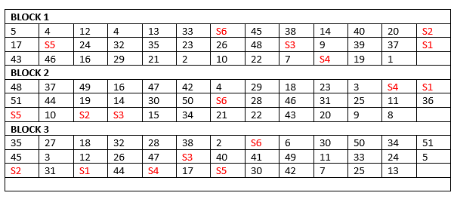
Figure 1. P-rep lay out for Sigatoka disease screening for the available 51 parental lines including checks

Step 4: Setting up the experiment (Research technician, Research assistant and pathologist)
4.1. Screen house evaluations (artificial inoculation)
- The Selected experimental site is prepared; which includes cleaning and disinfection if necessary.
- Planting bags (Poly bags) containing sterilized mixture of loam soil, manure and sawdust mixed in a ratio of 3:1:1 respectively, are placed at the experimental site following the experiment setup.
- Carefully transfer the weaned plants into planting bags (Polybags) following the experiment layout.
- Plants are left to fully grow for 3 months with regular watering and monitoring and then inoculated with P. fijiensis.
4.2. Pathogen isolation and maintenance
4.2.1. Sample collection
Samples are taken from leaves of diseased banana plants from the field consisting of leaf sections bearing numerous black Sigatoka disease lesions at Stages 2-4 (Lapeyre et al., 2017).

4.2.2. Pathogen isolation
Several protocols / methods can be used to obtain pure isolates of Pseudocercospora species (Lapeyre et al., 2017) (Refer to annex 2)

4.2.3. Inoculum preparation
Inoculations can either be done using mycelial suspension or conidial suspension (Refer to annex 3)
4.2.4. Artificial inoculation of banana plants (Abadie et al., 2008)
- Inoculate the youngest leaf on the lower surface using 1 ml of a spore suspension of 1 x 10⁵ spores /ml concentration using painters’ brush / camel brush or microsprayer
- Allow the inoculated area to dry for 1-2 hrs and then place plants into a humid chamber with 100% humidity for 48-96 hrs.
- Move the plants into the screen house and monitor plants for infection by studying the inoculated leaves for symptoms on a 5-day interval.
4.2.5. Data collection
Daily monitoring should be done to capture the time of appearance of the first symptom (small light green dots or dashes of approximately 1 mm in length). Data collection starts when the first symptom appears and is done on a 5-day interval.
Data captured includes:
- Incubation time (Time between inoculation with pathogen and appearance of symptoms)
- Disease severity after Gauhl scoring scale (Table 1).
- Symptom evolution time (Time from appearance of first symptom to development of mature spots).
- Symptom stages (Stover and Simmonds, 1987)
Table 1. Disease Severity after Gauhl scoring scale (Leiva-Mora et al., 2015)
Rating | Description
0  1  2  3  4  5  6 | No visible symptoms of the disease  Less than 1% (only streaks or up to ten spots of the leaf with disease symptoms)  1 to 5% of the leaf area with symptoms  6 to 15% of the leaf area with symptoms  16 to 33% of leaf area with symptoms  34 to 50% 0f the leaf area with symptoms  51 to 100% of the leaf area with symptoms

4.3. Field evaluations
- The experimental fields are established in areas where the disease pressure is high for natural infection. NB spreader rows of highly susceptible cultivars should be planted around and within the experiment.
- There should be a 2.5 m space between plants in each row and 3 m between rows.
- The trials should be managed according to the local farmers’ agronomic practices. Leaf spot diseases should not be controlled.
- The data should be collected for two successive cycles (on the mother plant and first sucker).
- The evaluation of resistance begins six months after planting (Kimunye et al., 2021)
- Every test plant, except the extra plants of the guard and spreader rows, should be used for data collection.

4.3.1 Data Collection
- Data collection should begin six months after planting.
- Data is captured at different growth stages on each plant i.e., vegetative stage, flowering stage and at harvesting stage. three months until the plant is harvested.
- Data is collected every after 3 months until the plant is harvested
- Data at flowering and at harvest should also be captured for every plant
- The following traits on each plant are captured: Total number of standing leaves (NSL), Total number of functional leaves (NFL), Youngest leaf with streaks (YLStr), Youngest leaf spotted (YLS), Disease severity index (DSI)
- Immediately Save and Export the weekly data collected from the Field book App into a Gmail Account/Dropbox/OneDrive or any other storage option for back up purposes

Step 5. Data Curation and Analysis
5.1 Disease grade
Disease grades should be recorded for each leaf on each test plant. Only upright leaves should be recorded (with petioles upright). Leaves should be graded using Gaul’s modification of Stover’s severity score system.
- 0 Healthy
- 1 < 1% leaf area affected (streaks and until 10 spots)
- 2 Until 5% of necrotic area
- 3 Between 6 and 15% of necrotic area
- 4 Between 16 and 33% of necrotic area
- 5 Between 34 and 50% of necrotic area
- 6 > than 51% of necrotic area

5.2 Disease severity index (DSI)
Disease severity is the amount of leaf area affected by Pseudocercospora leaf spots and can be expressed in disease grades or in percentage.
The black Sigatoka disease severity index for each plant is computed using the following formula: DSI = ∑ [nb ÷ (N − 1) T] × 100
Where:
n = number of leaves in each disease severity group/ grade,
b = severity group/grade;
N = number of severity groups used in the scale (7);
T = total number of leaves scored.
5.3 Index of non-spotted leaves
The proportion of healthy leaves or Index of non-spotted leaves (INSL) is estimated as the proportion of leaves rated in grade 0 of the total leaves assessed.
The index of non-spotted leaves is computed for each plant using the following formulae: INSL = [(YLS − 1) ÷ NSL] × 100
Where:
YLS = rank of the youngest leaf counting from bottom bearing at least 10 necrotic lesions with a dry centre,
NSL = the number of leaves starting from the youngest,
INSL = the proportion of standing leaves without the typical black Sigatoka late-stage necrotic lesions.

5.4 Area under disease progress curve (AUDPC)
The disease severity index (DSI) at different evaluation times is used to calculate the area under the disease progress curve (AUDPC) per cycle, using the formula:
AUDPC = ∑ni 1[(Xi + 1 + Xi) ÷ 2] [ti + 1 − ti]
Where Xi = disease severity index at i^{th} day,
ti = the time in days after appearance of the disease at ith day,
n = the total number of observations.

7. References
Abadie, C., Zapater, M. F., Pignolet, L., Carlier, J., & Mourichon, X. (2008). Artificial inoculation on plants and banana leaf pieces with Mycosphaerella spp., responsible for Sigatoka leaf spot diseases. Fruits, 63(5), 319–323.
Bananas (Tropical Agriculture Series): Stover, Robert H., Simmonds, N. W.: 9780470206843: Amazon.com: Books. (n.d.). Retrieved May 6, 2021, from https://www.amazon.com/Bananas-Tropical-Agriculture-Robert-Stover/dp/0470206845
Carlier, J., Zapater, M. F., Lapeyre, F., Jones, D. R., & Mourichon, X. (2000). Septoria leaf spot of banana: A newly discovered disease caused (anamorph Septoria eumusae) by Mycosphaerella eumusae. Phytopathology, 90(8), 884–890.
Chang, T. C., Salvucci, A., Crous, P. W., & Stergiopoulos, I. (2016). Comparative Genomics of the Sigatoka Disease Complex on Banana Suggests a Link between Parallel Evolutionary Changes in Pseudocercospora fijiensis and Pseudocercospora eumusae and Increased Virulence on the Banana Host. PLoS Genetics, 12(8).
de Lapeyre, L., Fouré, E., & Guillermet, C. (2017). Banana diseases and pests. In FruiTrop Focus.
Irish, B. M., Goenaga, R., & Ploetz, R. C. (2006). Mycosphaerella fijiensis, Causal Agent of Black Sigatoka of Musa spp. Found in Puerto Rico and Identified by Polymerase Chain Reaction. Plant Disease, 90(5), 684.
Kimunye, J., Jomanga, K., Tazuba, A. F., Were, E., Viljoen, A., Swennen, R., & Mahuku, G. (2021). Genotype X Environment Response of ‘ Matooke ’ Hybrids ( Naritas ) to Pseudocercospora fijiensis , the Cause of Black Sigatoka in Banana.
Leiva-Mora, M., Alvarado-Capó, Y., Acosta-Suárez, M., Cruz-Martín, M., Roque, B., & Mena Méndez, E. (2015). Components of resistance to assess Black Sigatoka response in artificially inoculated Musa genotypes. Rev. Protección Veg, 30(1), 60–69.

8. Annex: Forms/Templates to be used for monitoring and data collection
Annex 1: Flow Chart for Screening banana genotypes against P. Fijiensis (Black Sigatoka)

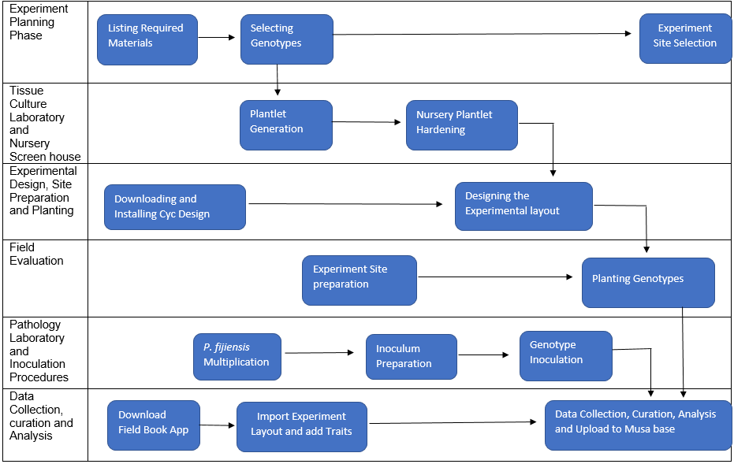

Annex 2: Procedure for pathogen isolation (Lapeyre et al., 2017)
- Select leaf material containing Stage 2 lesions of suspected, or Stage 2-3 for P. fijiensis and cut them into 1-2 cm squares.
- Immerse the tissue into a beaker containing 1% sodium hypochlorite for 1 min, remove and wash five times with sterile distilled water, blot dry using sterile blotting paper.
- Using a sterile scalpel blade, make incisions on either side of the lesion, taking care not to cut right through the leaf piece.
- Excise epidermal pieces of tissue (approximately 2 mm2), and plate onto PDA.
- Seal the Petri dish with Parafilm and incubate at 25ºC for 10 days.
- Transfer small portions (hyphal tips) of the culture to V8 media to induce conidia production.
- Mount the conidia on a glass slide and observe under a compound microscope to identify Pseudocercospora species

Annex 3: Procedure of inoculum preparation (Lapeyre et al., 2017)
3.1 Development of mycelial suspension
- From an actively growing monosporic culture on PDA, scrap mycelia directly into a sterile mortar with a surgical blade.
- Grind in 5 ml sterile distilled water with a drop of 0.05% Tween 20 into a fine suspension. Filter the suspension through two layers of cheesecloth to get rid of media debris.
- Quantify the suspension using a haemocytometer.
- Alternatively, harvested mycelia can be weighed on a balance, and fragmented by blending in sterile distilled water.

3.2 Development of spore suspension
- Add 3 ml of sterile distilled water with a drop of 0.05% Tween 20 to a sporulating culture (sporulating colonies appear pinkish).
- Dislodge the spores by lightly brushing on the surface of the colony.
- In case mycelial fragments have been dislodged too, sieve the suspension through double layers of cheesecloth.
- Quantify using a haemocytometer under a microscope and adjust to required concentrations using sterile distilled water.
- Prior to inoculation, add 1%v/v Triton X-100 to the inoculum suspension to enable mycelia and spores to adhere to the leaf surface.

